Guest Profile:

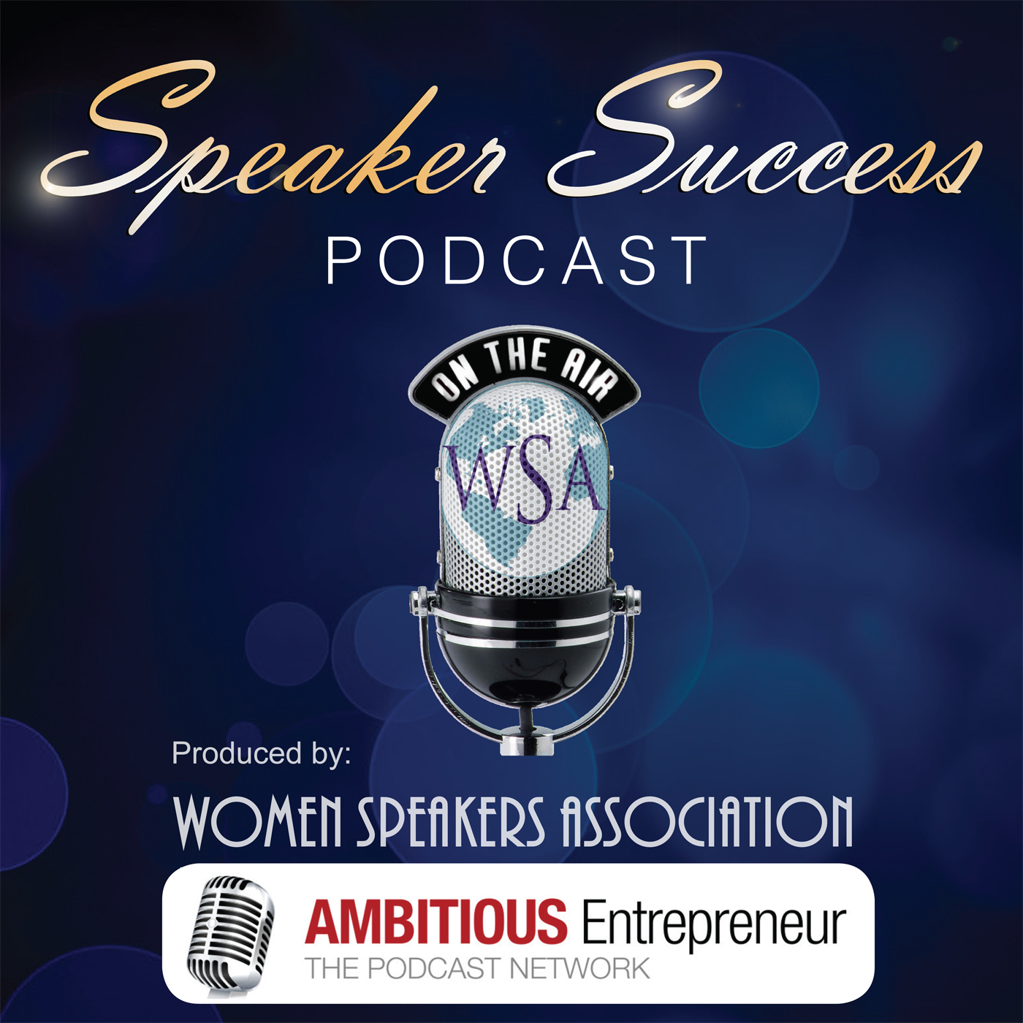
Thank you for agreeing to be interviewed on the show – Speakers Success Podcast: a bi-monthly podcast featuring inspiring women with a bold vision who are sharing their powerful insights to help other business women use speaking to build a thriving business.

Speakers Success Podcast is a collaboration between Women Speakers Association and the Ambitious Entrepreneur Podcast Network, who produces and hosts the show.
To recap on how your interview will be conducted and structured:
The interview will be conducted via Skype - audio only. Unlike a radio interview, which typically goes live to air, this interview is pre-recorded. So if you need to do a second-take, you can.
Your interview will be structured in a way that enables you to showcase your insights and information, so the questions I ask you will be centered around the key points you've provided in the Guest Profile.
Speaker Success Podcast has TWO specific themes:
- Our ‘Insights’ focused theme, where an expert, who works with and therefore supports speakers, shares their knowledge in order to educate and empower our listeners.
- Our ‘Highlights’ focused theme to inspire and empower listeners by hearing a member share their success stories. In particular the tools/techniques she has implemented and the successes she has been able to generate through doing so.
To help us prepare for your show, please answer the following questions.
Thank you!
Annemarie Cross – The Podcasting Queen: Your Host
 | Your Name:
Name | Click here to enter text.

A little about you: [no more than 100 words]
Click here to enter text.

 | Your contact details
Email | Click here to enter text.
Instagram | Click here to enter text.
Linkedin | Click here to enter text.
Twitter | Click here to enter text.
Facebook | Click here to enter text.
Website | Click here to enter text
Time Zone | Click here to enter text.
Link to your Free Gift | Click here to enter text.
Please also send us a professional image so we can include that in the graphics we use to promote the show. [No larger than 600x600 pixels].
What are 3 benefits/things our listeners will learn from you? We’ll be using this as a ‘hook’ at the beginning of our show and for the show blurb. The more benefit-driven, the more likelihood people will listen.
- Remember, we are looking for content that is thought provoking and reflects new ideas and insights to showcase your successes in order to inspire and empower businesswomen as they leverage speaking to grow a thriving business.
Please indicate whether you are contributing as an Expert to our Insights focused theme; or whether you are contributing as a Member to our Highlights focused theme.
Click here to enter text.

 | Benefits our listeners will gain from listening to you:
1. | Click here to enter text.
2. | Click here to enter text.
3. | Click here to enter text.

One of the things our team does as part of the promotion of your show, is to send out your quotes with the link back to your show. With that in mind, what are 3 quotes (things YOU say about what you will be speaking about in the show) we can use? Please add them below:
 | Your quotes (make sure they are created by you and not quotes someone else has said: Keep it short, tight and to the point if you can. Thank you!
1. | Click here to enter text.
2. | Click here to enter text.
3. | Click here to enter text.

Tell us about some of the interesting statistics*, opportunities etc going on in your industry that would be interesting to share with our listeners as I introduce you and open up the show. [This information will also help in the development of the show blurb.]
*When providing statistics please include references/web links so we can use these details in our show blurb and/or show itself.
 | Interesting statistics etc
1. | Click here to enter text.
2. | Click here to enter text.

WSA & AEPN Contact Details:
Women Speakers Association’s Twitter profile is: https://twitter.com/womenspeakassoc and Facebook Page is: https://www.facebook.com/WomenSpeakersAssociation
Along the promotion that Women Speakers Association will roll out - the Ambitious Entrepreneur Podcast Network’s goal is also to promote the show globally through our social media channels. If you would like to support us in doing this – please do!
- My personal Twitter & Instagram handle is: @AnnemarieCoach (www.Instagram.com/AnnemarieCoach)
- Ambitious Entrepreneur Podcast Network Twitter handle is: @TheAmbitiousPod (www.Twitter.com/TheAmbitiousPod )
- Our Facebook Page is: https://Facebook.com/TheAmbitiousEntrepreneurShow
Feel free to connect! You can then retweet our messages about your show.

IMPORTANT NOTE:
We assume that by completing and returning this Guest Profile, you give your permission for your interview to be recorded and used as part of our normal programming, which will be distributed on the internet.
Please type your name below to confirm you have read and agree with the above.
I agree: __________________
Thank you!

We look forward to receiving your profile. Please return your completed Guest Profile to my Guest Coordinator – Melissa @ sspguest@ambitiousentrepreneurnetwork.com
Next steps:
- Sound Tips Checklist: Download and review the Sound Tips Checklist so we can ensure the best possible sound quality for your interview.
- Access Annemarie’s online calendar: Click here, select an appropriate date and time, and follow the instructions to secure your booking. [Note: the interview will run for 30 minutes, however I've scheduled one-hour time slots on my calendar. I leave additional time between interviews in case there are technical hiccups we need to deal with, or if a guest is running late. If all goes well, we'll be finished within the 30 minutes and we can finish the call.]

